

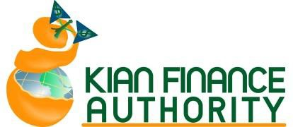




PREPARATORY Workshops in Hollywood




Become an Enrolled Agent and start a lucrative career

Convenient to meet your day to day job, the workshops are on weekdays and weekends (5 days Face-to-Face). Live Zoom participation.
Limited Space – Hollywood office
Invest on getting a license to practice before the IRS!

In just 5 short Weekdays/Weekends ZOOM or in person.

Kian Finance Authority is an IRS Continuing Education Provider. 2012 Hollywood Boulevard, Hollywood, FL 33020

Call to Register 954-399-8980 Enrolled Agent
(5 sessions to a higher expertise-- and higher Income for you.)
Unlike any online and unsupported course, this is an interactive, guided tour of the course to help you remember the topics and motivates you to pass. Invest in yourself (only $1,499) and you will reap 10 times over in the first year as an Enrolled Agent. You will also receive IRS credits for preparatory courses! You can register online- or copy and paste to the address bar:
http://fkianfa.com/enrolled-agent-see-exam/top by our office today!
Weekend Enrolled Agent Preparatory crash courses.
Register early to get your material.

Or just stop by our office today!
Fee: $1,499 thru Zelle


Educational materials and sample tests will be provided. All you need is dedication to 5 months of focused study to pass!
ALL THREE PARTS:
Part I. Individual
Part II. Business

Part III. Representation

99-898954-399-89800

Who is an Enrolled Agent?
Enrolled agents are just like attorneys and CPAs with two main differences. Enrolled Agents are specialized in taxation whereas attorneys or CPAs may or may not specialize in taxes. They may not be familiar with yearly amendments to the tax laws. More importantly, CPAs and attorneys may go on with their practice for years without ever updating their tax knowledge. Enrolled Agents must complete 72 hours of Continuing Education courses over every three years which Kian Finance Authority offers.

Enter into a career that can provide you with good income for life!
“Enrolled Agents have unlimited practice rights before the IRS, which means they can represent clients for ANY tax matter.”
www.irs.gov/Tax-Professionals

Part I. Individual II. BusinessPart III.

