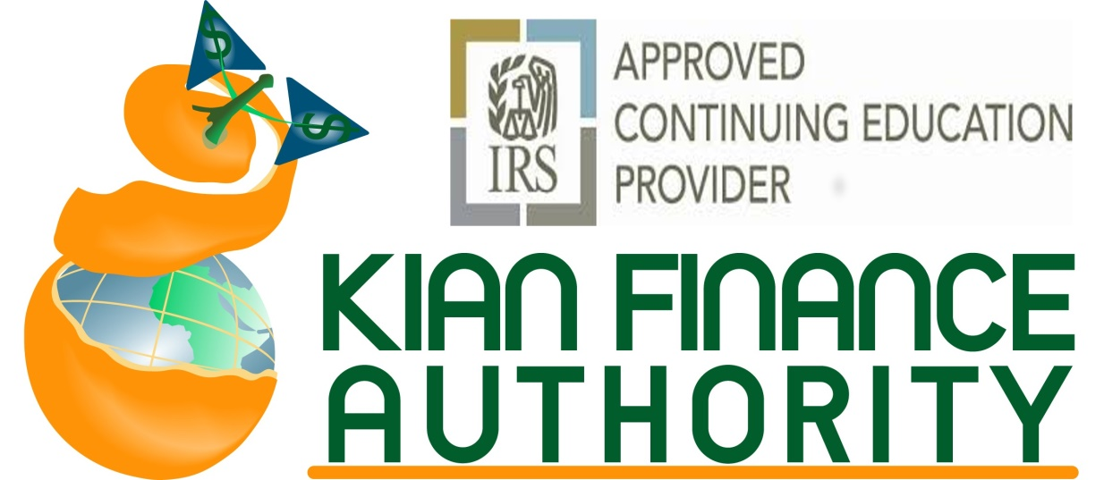
2012 Hollywood Boulevard, Hollywood, FL 33020

Bookkeeping, QB, Individual and Business Tax Workshops in 2019
Certifications of Participation will be issued, CE Credits will be reported to the IRS

Study Material and practice exams will be provided

10% Discounts for Early Registration on each class

- QuickBooks: one day $299
- Bookkeeping and Payroll Two Days: $399
- QuickBooks, Bookkeeping Payroll Crash course: 3 days: $599
- Enrolled Agent preparatory Workshops (5 Saturdays 9-4), $1,400
- CE Weekends (2 Saturdays Days 15 CE) for PTIN holders and Enrolled Agents. These courses are for Continuing Education Credits $799
- Beginner and Intermediate Individual tax workshops (3 Saturdays 9-4) $599
- Business tax (3 Saturdays 9-4), $699
- One day Business Tax Crash course: $299 (3 credit hours )
- Key West Tax Retreat for EAs and AFSP participants: July 12-13-14, 2019 $599
- FT. Lauderdale Tax Conference for EA and AFSP: October 25-27, 2019 $599
Online, self-studies and Internet courses for all above topics are also available. Please call 954-3 99-8980for enrollment and study material.

